CAS PY 106

InClass Note 24

1. General rules for strings and pipes
2. Fixed end is always a node (no movement)
3. Free end is always an anti-node (max movement)
4. Standing Waves in a pipe (open at both ends)
5. 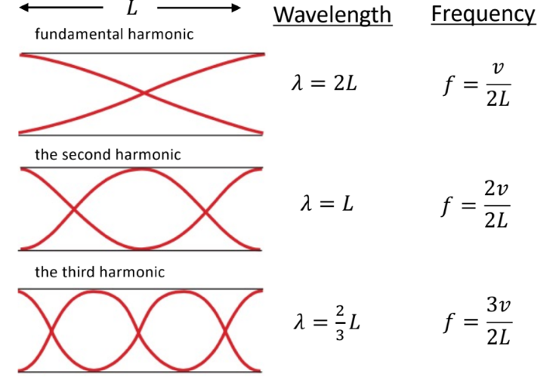
6. 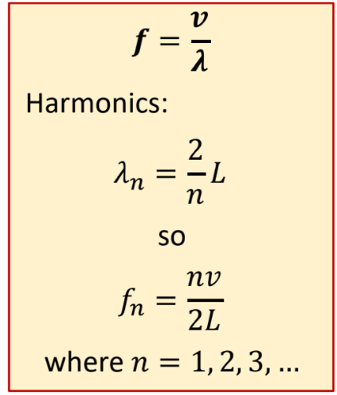
7. Standing Waves in a pipe (one end closed)
8. 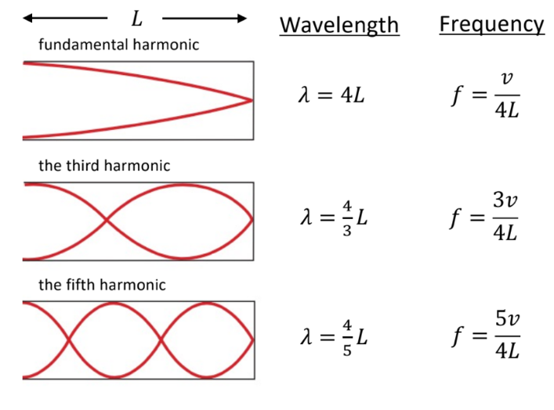
9. 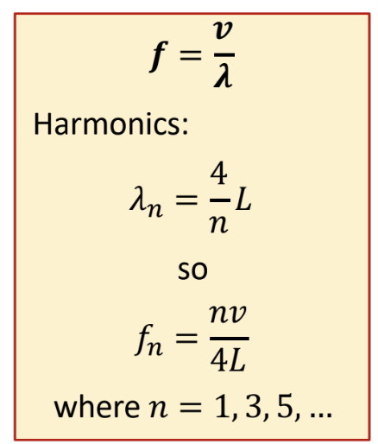
10. Standing Waves in a Pipe (closed at both ends)
11. 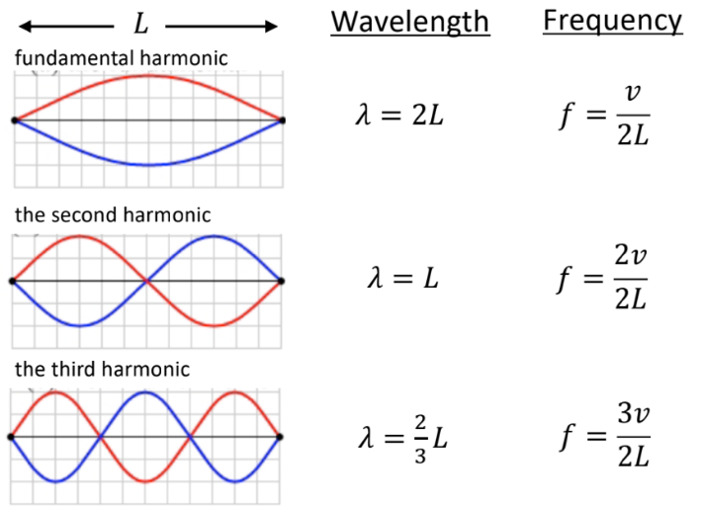
12. 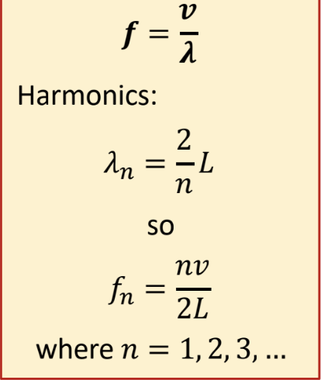
13. Wave in air
14. Speed of sound waves determined by the medium – you can’t change this
15. v = wavelength \* frequency
16. A room filled with air at 20oC then you’ll get a wave speed of 343m/s
17. String vibrating at a fundamental of 175 Hz (F-3)

Wavelength = v / frequency = 343/175 = 1.96m (at some intensity I1)

1. 2nd harmonic at 175 \* 2 = 350 Hz (F-4)

Wavelength = v / frequency = 343/350 = 0.98m (1/2 wavelength F-3, at some intensity I2)

1. 3rd harmonic at 175 \* 3 = 525 Hz (F-5)

Wavelength = v / frequency = 343/175 = 0.65m (1/3 wavelength F-3, at some intensity I3)